Neural Network Assignment -4
Name = Hema Rajput
Roll no = 24UADS1062
4. WAP to evaluate the performance of implemented three-layer neural network with variations in activation functions, size of hidden layer, learning rate, batch size and number of epochs.

import tensorflow as tf
import numpy as np
import matplotlib.pyplot as plt
from tensorflow.keras.datasets import mnist

# ==============================
# LOAD DATASET
# ==============================
(x_train, y_train), (x_test, y_test) = mnist.load_data()
# Normalize
x_train = x_train.reshape(-1, 784) / 255.0
x_test = x_test.reshape(-1, 784) / 255.0

# ==============================
# MODEL FUNCTION
# ==============================
def create_model(hidden1, hidden2, activation):
model = tf.keras.Sequential([
tf.keras.Input(shape=(784,)), # Correct input layer
tf.keras.layers.Dense(hidden1, activation=activation),
tf.keras.layers.Dense(hidden2, activation=activation),
tf.keras.layers.Dense(10) # output layer
])
return model

# ==============================
# TRAIN FUNCTION
# ==============================
def train_model(hidden1, hidden2, activation, lr, batch_size, epochs):
model = create_model(hidden1, hidden2, activation)
optimizer = tf.keras.optimizers.Adam(learning_rate=lr)
model.compile(
optimizer=optimizer,
loss=tf.keras.losses.SparseCategoricalCrossentropy(from_logits=True),
metrics=['accuracy']
)
history = model.fit(
x_train, y_train,
batch_size=batch_size,
epochs=epochs,
verbose=0,
validation_data=(x_test, y_test)
)
test_loss, test_acc = model.evaluate(x_test, y_test, verbose=0)
return history, test_acc
# ==============================
# PARAMETERS TO TEST
# ==============================
activations = ['relu', 'sigmoid', 'tanh']
hidden_sizes = [(128, 64), (256, 128)]
learning_rates = [0.001, 0.01]
batch_sizes = [128, 256]
epochs_list = [5, 10]
results = []

# ==============================
# EXPERIMENT LOOP
# ==============================
for act in activations:
for hs in hidden_sizes:
for lr in learning_rates:
for bs in batch_sizes:
for ep in epochs_list:
print(f"\nTraining: act={act}, hidden={hs}, lr={lr}, batch={bs}, epochs={ep}")
history, acc = train_model(
hs[0], hs[1],
act,
lr,
bs,
ep
)
results.append({
"activation": act,
"hidden": hs,
"lr": lr,
"batch": bs,
"epochs": ep,
"accuracy": acc
})
print("Accuracy:", acc)
# ==============================
# DISPLAY RESULTS
# ==============================
print("\n===== FINAL RESULTS =====")
for r in results:
print(r)

# ==============================
# PLOT EXAMPLE TRAINING CURVE
# ==============================
plt.plot(history.history['loss'], label="Train Loss")
plt.plot(history.history['val_loss'], label="Val Loss")
plt.legend()
plt.title("Training vs Validation Loss")
plt.xlabel("Epoch")
plt.ylabel("Loss")
plt.show()

Output
Training: act=relu, hidden=(128, 64), lr=0.001, batch=128, epochs=5
Accuracy: 0.9764000177383423

Training: act=relu, hidden=(128, 64), lr=0.001, batch=128, epochs=10
Accuracy: 0.9801999926567078

Training: act=relu, hidden=(128, 64), lr=0.001, batch=256, epochs=5
Accuracy: 0.9732999801635742

Training: act=relu, hidden=(128, 64), lr=0.001, batch=256, epochs=10
Accuracy: 0.9779000282287598

Training: act=relu, hidden=(128, 64), lr=0.01, batch=128, epochs=5
Accuracy: 0.9699000120162964

Training: act=relu, hidden=(128, 64), lr=0.01, batch=128, epochs=10
Accuracy: 0.9690999984741211

Training: act=relu, hidden=(128, 64), lr=0.01, batch=256, epochs=5
Accuracy: 0.9733999967575073

Training: act=relu, hidden=(128, 64), lr=0.01, batch=256, epochs=10
Accuracy: 0.9740999937057495

Training: act=relu, hidden=(256, 128), lr=0.001, batch=128, epochs=5
Accuracy: 0.9736999869346619

Training: act=relu, hidden=(256, 128), lr=0.001, batch=128, epochs=10
Accuracy: 0.9775999784469604

Training: act=relu, hidden=(256, 128), lr=0.001, batch=256, epochs=5
Accuracy: 0.9789000153541565

Training: act=relu, hidden=(256, 128), lr=0.001, batch=256, epochs=10
Accuracy: 0.9797999858856201

Training: act=relu, hidden=(256, 128), lr=0.01, batch=128, epochs=5
Accuracy: 0.9614999890327454

Training: act=relu, hidden=(256, 128), lr=0.01, batch=128, epochs=10
Accuracy: 0.9688000082969666

Training: act=relu, hidden=(256, 128), lr=0.01, batch=256, epochs=5
Accuracy: 0.9745000004768372

Training: act=relu, hidden=(256, 128), lr=0.01, batch=256, epochs=10
Accuracy: 0.974399983882904

Training: act=sigmoid, hidden=(128, 64), lr=0.001, batch=128, epochs=5
Accuracy: 0.9610000252723694

Training: act=sigmoid, hidden=(128, 64), lr=0.001, batch=128, epochs=10
Accuracy: 0.9728999733924866

Training: act=sigmoid, hidden=(128, 64), lr=0.001, batch=256, epochs=5
Accuracy: 0.9498999714851379

Training: act=sigmoid, hidden=(128, 64), lr=0.001, batch=256, epochs=10
Accuracy: 0.9664999842643738

Training: act=sigmoid, hidden=(128, 64), lr=0.01, batch=128, epochs=5
Accuracy: 0.9721999764442444

Training: act=sigmoid, hidden=(128, 64), lr=0.01, batch=128, epochs=10
Accuracy: 0.9743000268936157

Training: act=sigmoid, hidden=(128, 64), lr=0.01, batch=256, epochs=5
Accuracy: 0.9722999930381775

Training: act=sigmoid, hidden=(128, 64), lr=0.01, batch=256, epochs=10
Accuracy: 0.9746000170707703

Training: act=sigmoid, hidden=(256, 128), lr=0.001, batch=128, epochs=5
Accuracy: 0.9674000144004822

Training: act=sigmoid, hidden=(256, 128), lr=0.001, batch=128, epochs=10
Accuracy: 0.9781000018119812

Training: act=sigmoid, hidden=(256, 128), lr=0.001, batch=256, epochs=5
Accuracy: 0.9563000202178955

Training: act=sigmoid, hidden=(256, 128), lr=0.001, batch=256, epochs=10
Accuracy: 0.9726999998092651

Training: act=sigmoid, hidden=(256, 128), lr=0.01, batch=128, epochs=5Accuracy: 0.9717000126838684

Training: act=sigmoid, hidden=(256, 128), lr=0.01, batch=128, epochs=10
Accuracy: 0.9772999882698059

Training: act=sigmoid, hidden=(256, 128), lr=0.01, batch=256, epochs=5
Accuracy: 0.9746000170707703

Training: act=sigmoid, hidden=(256, 128), lr=0.01, batch=256, epochs=10
Accuracy: 0.9790999889373779

Training: act=tanh, hidden=(128, 64), lr=0.001, batch=128, epochs=5
Accuracy: 0.9718000292778015

Training: act=tanh, hidden=(128, 64), lr=0.001, batch=128, epochs=10
Accuracy: 0.9779999852180481

Training: act=tanh, hidden=(128, 64), lr=0.001, batch=256, epochs=5
Accuracy: 0.9704999923706055

Training: act=tanh, hidden=(128, 64), lr=0.001, batch=256, epochs=10
Accuracy: 0.9760000109672546

Training: act=tanh, hidden=(128, 64), lr=0.01, batch=128, epochs=5
Accuracy: 0.9513000249862671

Training: act=tanh, hidden=(128, 64), lr=0.01, batch=128, epochs=10
Accuracy: 0.9656000137329102

Training: act=tanh, hidden=(128, 64), lr=0.01, batch=256, epochs=5
Accuracy: 0.9643999934196472

Training: act=tanh, hidden=(128, 64), lr=0.01, batch=256, epochs=10Accuracy: 0.9649999737739563

Training: act=tanh, hidden=(256, 128), lr=0.001, batch=128, epochs=5
Accuracy: 0.9740999937057495

Training: act=tanh, hidden=(256, 128), lr=0.001, batch=128, epochs=10
Accuracy: 0.978600025177002

Training: act=tanh, hidden=(256, 128), lr=0.001, batch=256, epochs=5
Accuracy: 0.9718000292778015

Training: act=tanh, hidden=(256, 128), lr=0.001, batch=256, epochs=10
Accuracy: 0.9804999828338623

Training: act=tanh, hidden=(256, 128), lr=0.01, batch=128, epochs=5
Accuracy: 0.9427000284194946

Training: act=tanh, hidden=(256, 128), lr=0.01, batch=128, epochs=10
Accuracy: 0.944100022315979

Training: act=tanh, hidden=(256, 128), lr=0.01, batch=256, epochs=5
Accuracy: 0.9648000001907349

Training: act=tanh, hidden=(256, 128), lr=0.01, batch=256, epochs=10
Accuracy: 0.965399980545044
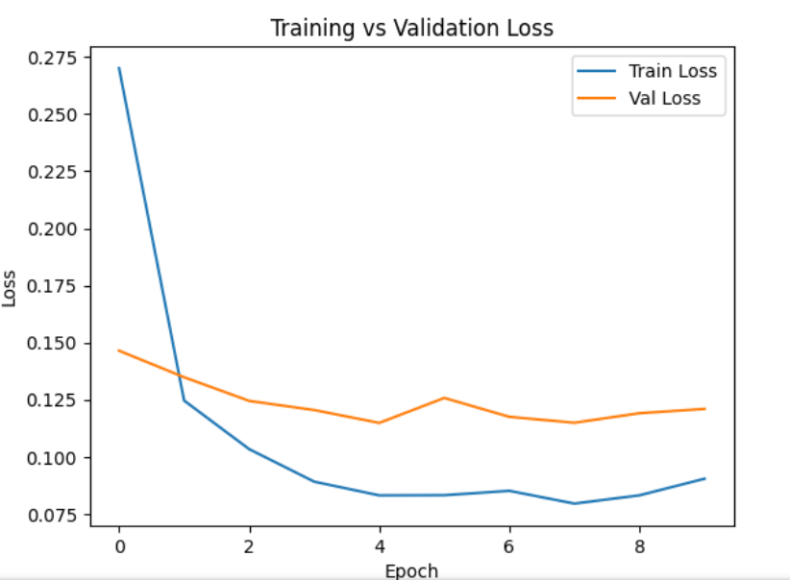
## Comment ##
What I learned from this code:
From this experiment I have learned when I change parameters it's affect the performance of my neural network and I also learned how the activation function like ReLU sigmoid and Tanh play important role that how a model learn something and how a neuron in hidden layer can change the accuracy I also anyalise that when I increase the neuron the modelcan learn better and know about little bit of learning rate and how the fast the model update it's weight and batch size which tell me how much data is processed at one time
Problem I have faced
When I performed the experiments I faced some problem with the model syntax while defining the input layer in tension flow and also I got some warnings in keras which confused me first why this warning show

